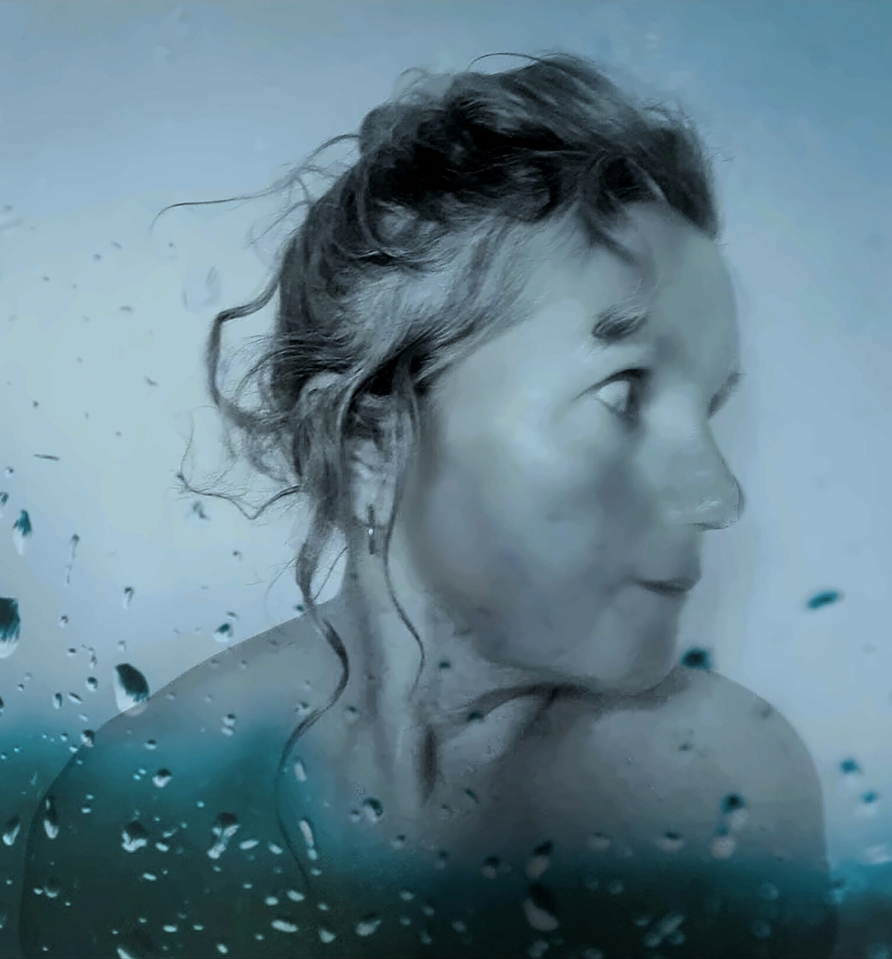


Susie Lewis Cornish Singer Songwriter
Media Information
Susie Lewis is a singer songwriter and actor from Cornwall, UK. She has worked in theatre, film and television. She has toured extensively as a solo artist, a member of a cabaret duo and as a choir leader. In recent years, she has released four solo albums, Fish Tales, Swan Songs, Dog Days and The Cats Whiskers all on Four Monkeys Records.
Career
Susie was born and educated in London, UK. She toured the UK and Europe as a member of the Miracle Theatre and the A39 Theatre Group. She has led a Cornish Community Choir for many years. Susie was the leading lady in several summer season productions at the Falmouth Pavilion. She has had numerous small roles in television including the BBC production of Poldark Her movie career has include Mrs Green in Welcome to Curiosity and many roles in independent film.
Fish Tales
Fish Tales was Susie's first solo album for Four Monkeys Records, released in November 2022. All songs were written by Susie and are stories about Cornwall and the people who live there. The album was produced by Ian David and the cover art was an original painting by the Cornish Artist Vonny Carter.
Swan Songs
Swan Songs is the second solo album by Susie Lewis for Four Monkeys Records released in August 2023. The songs were solo compositions or written in collaboration with her producer Ian David. The tracks on Swan Songs deal with love, loss and her dissatisfaction with modern politics. The cover art for the album was an original painting by Moira Leedham.
Bless The Poor
Susie's Christmas single, Bless The Poor, entered the UK charts in December 2023
Dog Days
Susie released her third solo album, Dog Days, for Four Monkey Records in May 2024. Again, the songs are a mixture of solo compositions and collaborations with her producer Ian David. She describes many of the tracks as "messed up love songs for mature women". This album features Geoff Atherton, the Yorkshire saxophonist and the art work is by the Cornish artist Deborah Prosser.
Better World
Better World is Susie's Christmas single for December 2024. Proceeds from the single go to the Better World Charity.
The Cats Whiskers
Susie’s fourth solo album, The Cats Whiskers, was released on Four Monkeys Records in June 2025. The original compositions are all short stories, real or imaginary. Again the album was produced by Ian David and features contributions by the Jazz Bass Player Dean Pearson and the Saxophonist Geoff Atherton. The cover features a work by the artist Ann Oxley.
The Playing Place
Susie's fifth album was released on Four Monkeys Records in June 2026. Named after the village in which she lives, this is a collection of humorous and poignant songs describing love, in all its many guises. Again, written in partnership with her producer, Ian David, the music covers a wide variety of styles from pop to jazz, latin to choral work. The artwork is by Cornish artist Lizzie Stevens.
Tours
Susie completed successful UK tours in August and September 2023, February 2024, July & August of 2024 and December 2024. In the Summer of 2025, Susie is performing at several Music Festivals. In 2026, Susie is undertaking more festival appearances and a series of outdoor community concerts throughout the South West of England.
https://www.fourmonkeysrecords.com https://www.susielewiscornwall.com

